# **Impermanent Loss –**

Automated market maker (AMM) technology has taken off in spite of one of DeFi’s dirty secrets: Users who provide liquidity to AMMs can see their staked tokens lose value compared to simply holding the tokens on their own.

Simply put, impermanent loss is the difference between holding tokens in an AMM and holding them in your wallet.

It occurs when the price of tokens inside an AMM diverge in any direction. The more divergence, the greater the impermanent loss.

Why “impermanent”?

Because as long as the relative prices of tokens in the AMM return to their original state when you entered the AMM, the loss disappears and you earn 100% of the trading fees.However, this is rarely the case. More often than not, impermanent loss becomes permanent, eating into your trade income or leaving you with negative returns.

# How Does It Occur?

To understand how impermanent loss occurs, we first need to understand how AMM pricing works and the role arbitrageurs play.

In their raw form, AMMs are disconnected from external markets. If token prices change on external markets, an AMM doesn’t automatically adjust its prices. It requires an arbitrageur to come along and buy the underpriced asset or sell the overpriced asset until prices offered by the AMM match external markets. During this process, the profit extracted by arbitrageurs is effectively removed from the pockets of liquidity providers, resulting in impermanent loss. For example, consider an AMM with two assets, ETH and DAI, set at a 50/50 ratio. As shown below, a change in the price of ETH opens an opportunity for arbitrageurs to profit at the expense of liquidity providers.

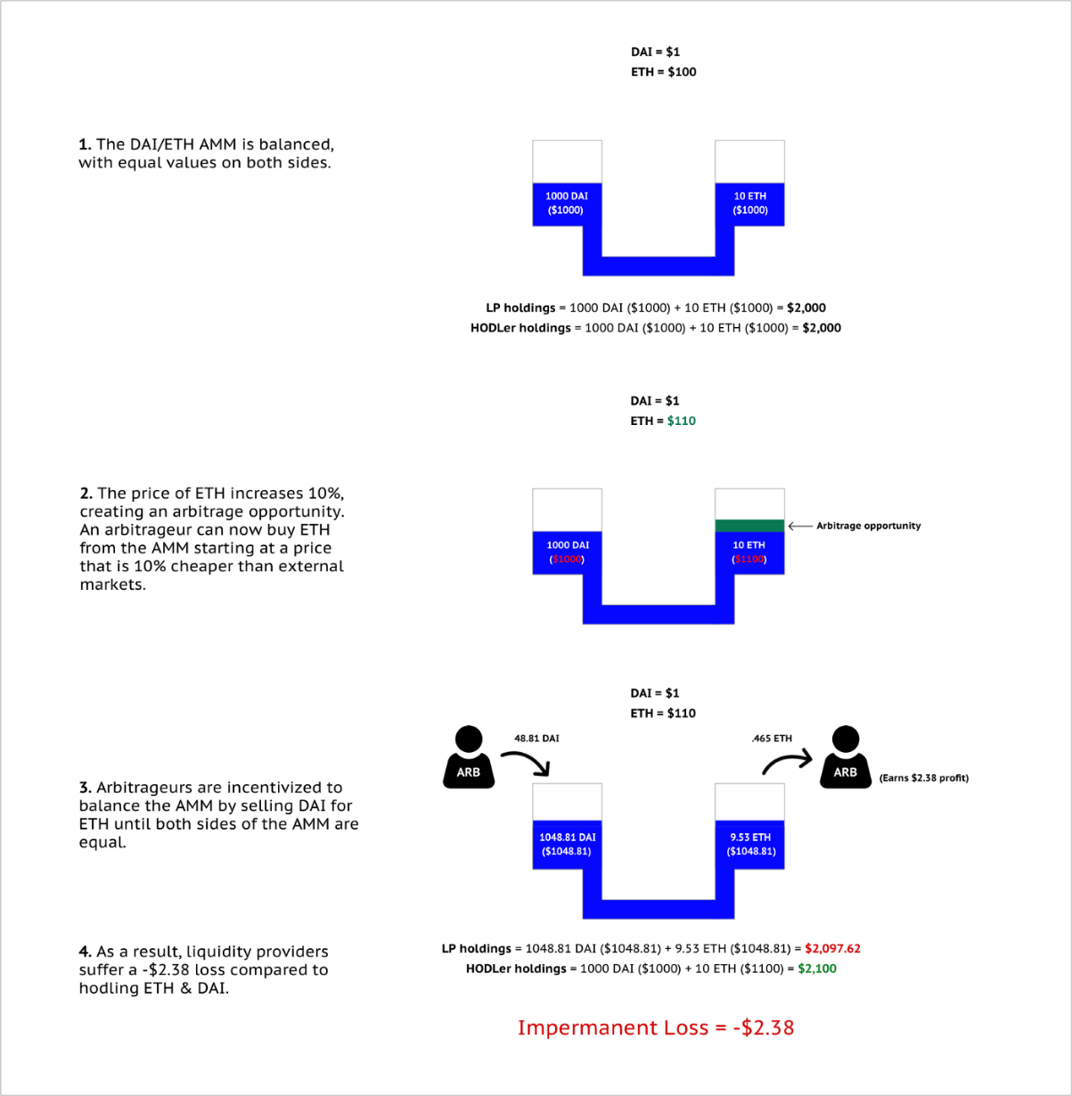

If you examine different price movements, you can see that even small changes in the price of ETH cause liquidity providers to suffer impermanent loss:

Clearly this is an issue that needs to be addressed if AMMs are to achieve widespread adoption among everyday users and institutions.

If users are expected to constantly monitor and act on changes in the AMM to avoid significant losses, liquidity provision becomes a game that is reserved for only the most advanced traders (see: traditional finance).

**What Is Bancor?**

Bancor is a [blockchain](https://www.investopedia.com/terms/b/blockchain.asp) protocol that allows users to convert different virtual currency tokens directly and instantly instead of exchanging them on cryptocurrency exchanges like [Coinbase](https://www.investopedia.com/tech/coinbase-what-it-and-how-do-you-use-it/).

Bancor invented the world's first blockchain-based automated liquidity pool, or automated market maker (AMM) called a Smart Token, a digital currency with an embedded converter (smart contract) that allows it to be issued or exchanged automatically for any token in its network.

### **KEY TAKEAWAYS**

* Bancor is a decentralized financial network that seeks to provide liquidity to small- and micro-cap coins and returns for liquidity providers.
* Bancor utilizes two token layers that facilitate its liquidity pools and functionality: BNT and ETHBNT.
* Bancor and its competitor Uniswap are the leaders in a new wave of decentralized financial systems.

Bancor Network Token (BNT)

Bancor's purpose is to remove the middleman by creating a virtual reserve currency, which they call Bancor Network Token (BNT), and an automatic exchange mechanism where prices and trading volumes are controlled automatically through the protocol.5

﻿

Bancor's native reserve currency token, BNT, is the default reserve currency for all smart tokens created on the Bancor network.5﻿ One of the promises of BNT's ICO was that investors in the coin would gain interest on the transaction fees as other crypto coins are converted into and out of BNT.

## Criticisms of Bancor

Internally, the Bancor network uses the concept of Constant Reserve Ratio (CRR) in all smart token contracts, which purports to eliminate the possibility of the reserve value of smart tokens being depleted. The rate of conversion between various crypto coins is fairly maintained by various formulas and algorithms internally implemented by the Bancor network.

The claim that Bancor guarantees liquidity is contested, however. A pseudonymous blogger "bitcoinchaser" points out that "The level of cryptocurrency liquidity that Bancor has, is relative. If there is a massive run on the token or any other token under it, its price will plummet, and that 20% reserve will be wiped out in minutes.

# **Guide: How to Stake Liquidity in Bancor Pools**

* The success of the Bancor Protocol depends on users staking tokens in Bancor liquidity pools and generating fees from trade volume.
* Compared to other DeFi liquidity pools, Bancor offers several unique features to users including **single-token exposure** and **impermanent loss protection**.
* Other pools require users to contribute equal amounts of two tokens, and expose the user to the risk of loss in their principal staked value if one of the tokens rises in price (i.e., impermanent loss).
* On Bancor, users contribute only one asset and maintain 100% exposure to the asset, while remaining fully protected from impermanent loss and earning yield from trading fees up to 40% APR.
* These features make Bancor particularly attractive to users seeking a safe and simple way to earn passive income on the tokens they love, without having to worry about market volatility causing losses in their principal staked value.

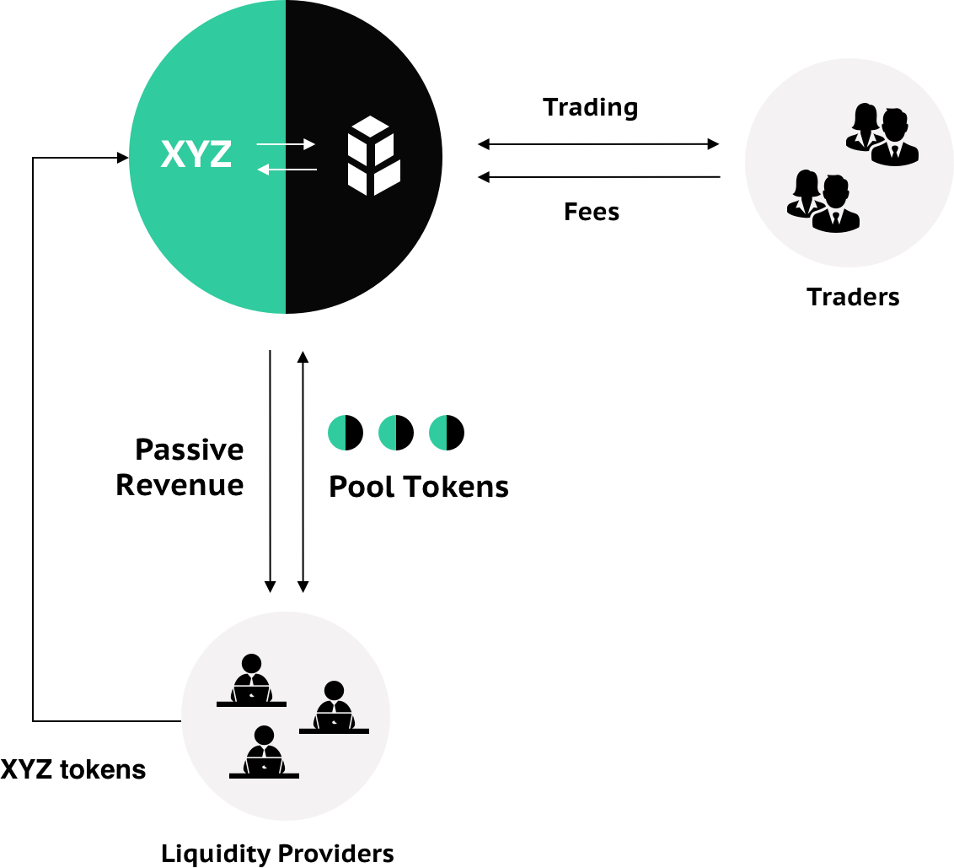

**How to protect yourself from impermanent loss with Bancor –**

Unlike other AMMs like Uniswap or Balancer, Bancor uses its protocol token, BNT, as the counterpart asset in every pool. With last week’s introduction of Bancor v2.1, BNT evolved into an elastic supply token. This new protocol functionality allows Bancor to offer two key features to AMM liquidity providers: single-asset exposure and impermanent loss insurance.

Users who provide liquidity to Bancor pools can stay long on their tokens while collecting swap fees and liquidity mining rewards, without having to live in fear of impermanent loss.

**What’s new with Bancor v2.1**

In an effort to solve this issue, Bancor piloted a dynamic weighting system earlier this year that utilized oracles in order to mitigate the risk. The strategy was quickly adopted by several newer AMM protocols. However, we soon found (and have since seen our peers discover) that adjusting weights based on a price feed actually increases the risk of IL in certain market conditions, due to arbitrageurs moving faster than any price feed can update the pool.

In Bancor v2.1, we decided to take a different approach.

The protocol co-invests BNT alongside liquidity providers so when an LP supplies liquidity to a given pool, the protocol provides an equal value of BNT to the other side of the pool.

The protocol generates fees off this liquidity, which are eventually burned along with the co-invested BNT whenever the LP withdraws their liquidity. The burned fees are used to compensate the LP for any impermanent loss on their stake when they withdraw, while any excess burned fees are used to reduce the overall supply of BNT (benefitting all BNT holders).

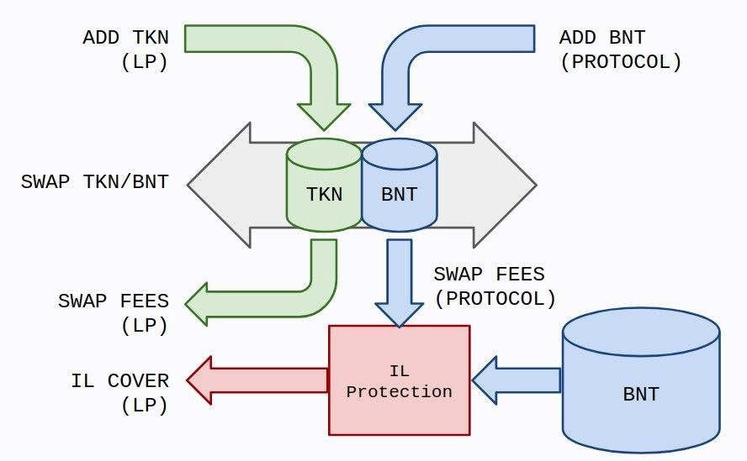

Notably, a BNT holder can always provide their BNT to a pool, which effectively takes over the protocol’s position in the pool and burns the co-invested BNT along with its earned fees.

For both LPs providing the “risk” asset (i.e., single-sided ERC20 liquidity), protection against impermanent loss accrues over time. The longer you remain in the pool, the more IL insurance you earn. The system’s default settings have LP’s impermanent loss insurance growing by 1% each day until they reach 100%, and are fully protected thereafter.

Keep in mind you can withdraw liquidity at any time, you just may be exposed to some IL—for instance, withdrawing liquidity 30 days after staking would result in 30% coverage against any IL.

**References –**

[**https://blog.bancor.network/how-to-stake-liquidity-earn-fees-on-bancor-bff8369274a1**](https://blog.bancor.network/how-to-stake-liquidity-earn-fees-on-bancor-bff8369274a1)

**https://newsletter.banklesshq.com/p/how-to-protect-yourself-from-impermanent?s=r**

# **Uniswap**

Uniswap uses Constant Product Market Maker (CPMM) to determine price.

Liquidity providers create a market by depositing an equivalent value of two tokens. These can either be ETH and an ERC-20 token or two ERC-20 tokens. These pools are commonly made up of [stablecoins](https://academy.binance.com/en/articles/what-are-stablecoins" \t "_blank) such as DAI, USDC, or USDT, but this isn’t a requirement. In return, liquidity providers get “liquidity tokens,” which represent their share of the entire liquidity pool. These liquidity tokens can be redeemed for the share they represent in the pool.

So, let’s consider the ETH/USDT liquidity pool. We’ll call the ETH portion of the pool **x** and the USDT portion **y**. Uniswap takes these two quantities and multiplies them to calculate the total liquidity in the pool. Let’s call this **k**. The core idea behind Uniswap is that **k** must remain constant, meaning the total liquidity in the pool is constant. So, the formula for total liquidity in the pool is:

**x \* y = k**

So, what happens when someone wants to make a trade?

Let’s say Alice buys 1 ETH for 300 USDT using the ETH/USDT liquidity pool. By doing that, she increases the USDT portion of the pool and decreases the ETH portion of the pool. This effectively means that the price of ETH goes up. Why? There is less ETH in the pool after the transaction, and we know that the total liquidity (**k**) must remain constant. This mechanism is what determines the pricing. Ultimately, the price paid for this ETH is based on how much a given trade shifts the ratio between **x** and **y**.

It’s worth noting that this model does not scale linearly. In effect, the larger the order is, the more it shifts the balance between **x** and **y**. This means that larger orders become exponentially more expensive compared to smaller orders, leading to larger and larger amounts of [slippage](https://academy.binance.com/en/articles/a-complete-guide-to-cryptocurrency-trading-for-beginners#what-is-slippage-in-trading). It also means that the larger a liquidity pool is, the easier it is to process large orders. Why? In that case, the shift between **x** and **y** is smaller.

## Uniswap v3

One of the most significant changes coming with Uniswap v3 relates to capital efficiency.

Liquidity providers can now set custom price ranges for which they want to provide liquidity for. This should lead to more concentrated liquidity in the price range that most trading activity happens in.

In some sense, Uniswap v3 is a rudimentary way of creating an on-chain order book on Ethereum, where market makers can decide to provide liquidity in the price ranges they set. It’s worth noting that this change favors professional market makers over retail participants. The beauty of AMMs is that anyone can provide liquidity and put their funds to work.

However, with this additional layer of complexity, “lazy” LPs are going to earn much less in trading fees than professional players who can constantly keep optimizing their strategy

**Pros:**Uniswap V3 introduces the concept of liquidity distribution, by allowing its users to deposit liquidity in price ranges. By concentrating liquidity, it improves the capital efficiency. Higher liquidity and lower slippage are achieved when depositing the same value of assets. Providing liquidity in a price range also in some way lowers the risk of impermanent loss.

**Cons:**Users can only deposit certain types of token when doing range orders. Buy-stop order and stop-loss order therefore can not be realized.

**Balancer**

[Balancer](https://balancer.fi/whitepaper.pdf)⁸ extends 2-token pools of Uniswap V2 to multi-token pools. The value of each type of asset in a Balancer pool holds an invariant weight that adds up to 1. It is not hard to show that this is equivalent to the power product of the reserve number of each asset is a constant. The Balancer is a multi-token automated market-making protocol. It allows the platform users to swap tokens, add liquidity to an existing pool, and create a new pool.

The Balancer pools can be created by using two or multiple tokens and allow the users to set token weight that represents each token proportion out of the total pool value. The user provides liquidity in the Balancer pool and receives pool tokens proportional to their pool’s liquidity.

Balancer also introduces the Smart Order Router ([SOR](https://docs.balancer.fi/developers/smart-order-router)⁹) algorithm.

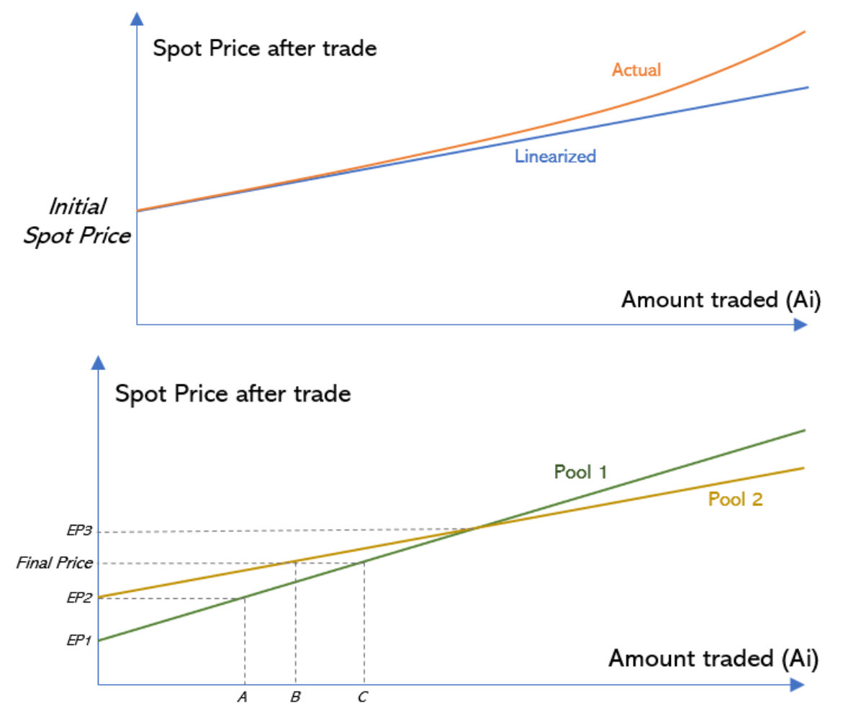

The general idea of this algorithm is to divide an order into several small pieces to trade in different Balancer pools, to achieve a better swap result. Suppose we want to trade in pool 1 and pool 2. If the total amount **N**we want to trade is below **A** in the above figure, we will only trade in pool 1, as the price in pool 1 is always better than the price in pool 2. If the total amount exceeds **A**, we will trade part of the order in pool 1 and part in pool 2. The amount traded in each pool will bring the price in each pool equal (**B** + **C** = **N**).

It is easy to prove the optimal strategy is always the one that brings the price in each pool equal (if the price is not equal, we can always find a pool with better price to improve our swap result).

**Balancer Governance Token (BAL)**

The Balancer native governance token, [BAL](https://www.coingecko.com/en/coins/balancer), can be used for governance activities, i.e., to vote on proposals, etc. Every week, 145,000 BALs, or approximately 7.5 million per year, are distributed to liquidity providers. They are typically distributed directly to liquidity providers on Tuesdays at 2300 UTC.

**Balancer Pool**

The Balancer pool is the core of the Balancer Protocol. These pools are the smart contracts that help in the proper functioning of the Balancer Protocol.

Balancer pools can be created with two or more ERC20 tokens. **At a time, you can add a max of 8 tokens to create a pool**. The Balancer pool user also has the flexibility to customize the token weight while creating a pool. For example, you can create a pool with three tokens in the following proportions: 50% WETH, 25% USDT, and 25% DAI.

**Balancer Pool Creation Limitations**

* Users can add a max of 8 tokens.
* The swap fee must be between 0.0001% and 10%.
* Pool tokens must be ERC20 compliant.

**Types Of Balancer Pools**

The Core Balancer Pools are controlled by a smart contract and can be divided into the categories below:

* **Finalized/Public**— The pool parameters (asset types, weights, and fees) are fixed, and anyone can add/remove liquidity and swap tokens.
* **Controlled/Private**— Controlled pools are solely managed by a “controller” address. Only this address can add or remove liquidity to the pool (call join or exit). The pool parameters are not fixed, i.e., the pool asset types and their weights can be changed.

**Pros:**Balancer generalizes 2-token pools to multi-token pools, and introduces the SOR algorithm to achieve better prices for its users.

**Cons:** “A liquidity pool is only as strong as its weakest asset.” The more types of tokens in one pool, the higher the risk.

**Curve –**

Like Uniswap, Curve is a decentralized exchange for trading cryptocurrency assets. The key difference between them is that on Uniswap, you can swap any [ERC-20 token](https://www.coindesk.com/what-is-the-erc-20-ethereum-standard) (as long as there’s liquidity), whereas Curve is specifically for trading stablecoins on Ethereum.

* Low trading fees — Curve offers traders far lower trading fees for stablecoin trades than Uniswap (0.3% per trade at Uniswap vs. 0.04% on Curve).
* Minimized slippage — Whale traders and high-volume trading pairs are subject to slippage, but Curve’s similar asset pools minimize this.
* No impermanent loss — Liquidity providers on Curve supply stablecoin pairs that nearly eliminate impermanent loss.

Curve merges Constant Sum Market Maker (CSMM) and Constant Product Market Maker (CPMM) together to achieve lower price slippage. We can think of this algorithm as adding a constant price part to the Uniswap/Balancer model to make the resulting function pegged to a certain price.

Curve¹⁰ V1, known as StableSwap, designs its algorithm for stablecoin trading.

The CPMM and the dynamic weight in this model are used to punish informed extremely large orders, preventing tokens in the pool to be completely sold out.

**Pros:**By adding CSMM and CPMM together with dynamic weight, Curve’s StableSwap achieves very small slippage, ideal for stablecoins. **Cons:**The price is always pegged at 1. The pool will be bought out if the market price significantly differs from the pool price. Therefore, StableSwap only works for stablecoins.

**Curve V2**

Curve’s StableSwap and dynamic peg V2 are here to make the trading slippage as small as possible. StableSwap always pegs at 1 while V2 makes the pegs follow the market price.

**Pros:**The market maker function can be pegged to any price, which suits all the tokens instead of only stablecoins. The price transition is smoother than StableSwap. Curve V2 also constantly updates the price scale, according to its internal price oracle, to better represent the market price, and ensure trading near the equilibrium point. Dynamic fees make sure a even better price on top of this.

**Cons:**Gas fees could be higher due to solving cubic and sextic equations. Repegging based solely on its internal price oracle could be risky. We wonder if there are scenarios where the price scale is noticeably different from the market price while passing the **Xcp** criteria. Cross-checking the price with other oracles could help if that is the case.